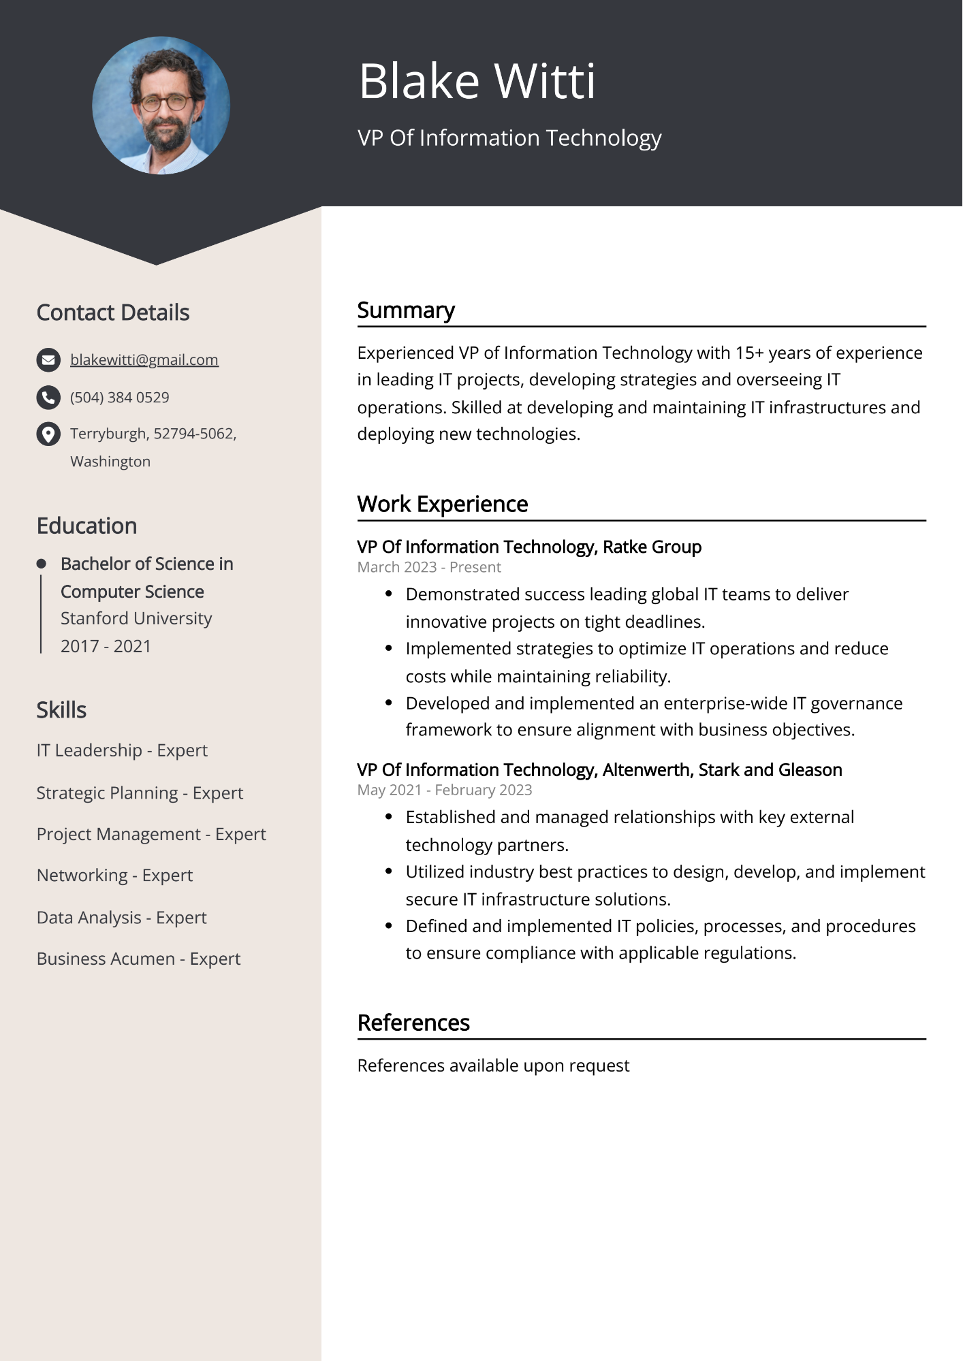
Blake Witti
VP Of Information Technology
Contact Details
blakewitti@gmail.com
(504) 384 0529
Terryburgh, 52794-5062, Washington
Education
• Bachelor of Science in Computer Science
Stanford University
2017-2021
Skills
IT Leadership - Expert
Strategic Planning - Expert
Project Management - Expert
-
Networking - Expert
Data Analysis - Expert
Business Acumen - Expert
Summary
Experienced VP of Information Technology with 15+ years of experience in leading IT projects, developing strategies and overseeing IT operations. Skilled at developing and maintaining IT infrastructures and deploying new technologies.
Work Experience
VP Of Information Technology, Ratke Group
March 2023 - Present
Demonstrated success leading global IT teams to deliver
innovative projects on tight deadlines.
Implemented strategies to optimize IT operations and reduce costs while maintaining reliability.
• Developed and implemented an enterprise-wide IT governance framework to ensure alignment with business objectives.
VP Of Information Technology, Altenwerth, Stark and Gleason May 2021 - February 2023
• Established and managed relationships with key external technology partners.
• Utilized industry best practices to design, develop, and implement secure IT infrastructure solutions.
• Defined and implemented IT policies, processes, and procedures to ensure compliance with applicable regulations.
References
References available upon request

